**Project Design Phase**

**Solution Architecture**

|  |  |
| --- | --- |
| Date | 24 June 2025 |
| Team ID | LTVIP2025TMID35409 |
| Project Name | HematoVision: Advanced Blood Cell Classification Using Transfer Learning |
| Maximum Marks | 4 Marks |

**Solution Architecture:**

Solution architecture is a complex process – with many sub-processes – that bridges the gap between business problems and technology solutions. Its goals are to:

●  **Find the best tech solution to solve existing medical challenges**  
HematoVision leverages MobileNetV2 with a Flask interface to automate blood cell classification and reduce manual errors.

●  **Describe the structure, characteristics, behavior, and other aspects of the system**  
The system includes modules for image upload, preprocessing, prediction, and result display tailored for clinical workflows.

●  **Define features, development phases, and solution requirements**  
Key features include real-time prediction, user interface, and report generation, developed in stages from model training to deployment.

●  **Provide specifications for how the solution is defined, managed, and delivered**  
The model accepts images, resizes to 244×244, classifies into four types, and returns results through a web interface with storage support

**Example - Solution Architecture Diagram:**

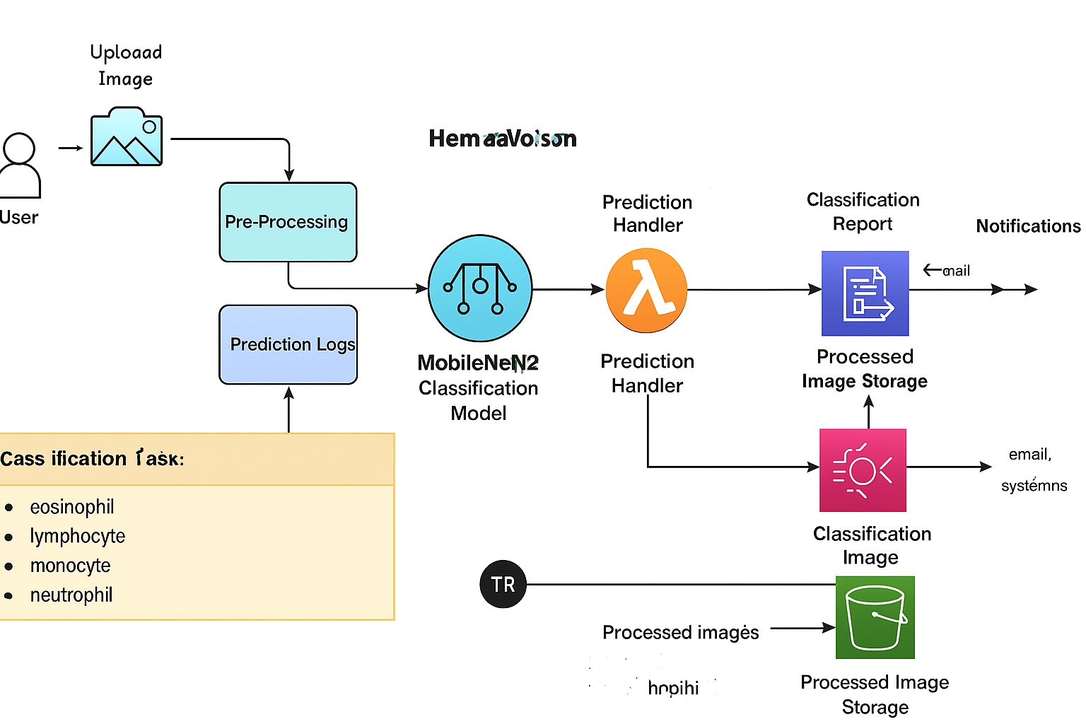

***Figure 1:*** *Architecture and data flow of the HemetoVision: Advanced BloodCell Classification Using transfer Learning*